
Presented to:
Miss Kawthar dokmak
Prepared by:
Ghadeer Khalaf
22230345
School Of Arts and Sciences
Computer Science Department

CSCI351 – Concept of Programming
Project-2

Part 1: Java program
Question-1:
* @author Ghadeer
*/
import java.util.Scanner;
public class Project2 {
public static void main(String[] args) {
Scanner scan = new Scanner(System.in);
Student[] students = new Student[3];

for (int i = 0; i < students.length; i++) {
System.out.print("Enter student name: ");
String name = scan.nextLine();

System.out.print("Enter student grade (0 to 100): ");
int grade = scan.nextInt();
scan.nextLine();

students[i] = new Student(name, grade);
}

System.out.print("Enter index (0 to 2) to display student grade info: ");
int index = scan.nextInt();

if (index >= 0 && index < students.length) {
String result = students[index].getGradeLevel();
System.out.println("Student " + students[index].getName() + " is: " + result);
} else {
System.out.println("Invalid index!");
}

System.out.println("\nStudents with grade > 90:");
for (int i = 0; i < students.length; i++) {
if (students[i].getGrade() > 90) {
System.out.println(students[i].getName() + " - " + students[i].getGrade());
}
}
}

public static class Student {
private String name;
private int grade;

public Student(String n, int g) {
name = n;
grade = g;
}

public String getName() {
return name;
}

public int getGrade() {
return grade;
}

public String getGradeLevel() {
if (grade >= 90) return "Excellent";
else if (grade >= 75) return "Good";
else if (grade >= 60) return "Average";
else return "Failing";
}
}
}

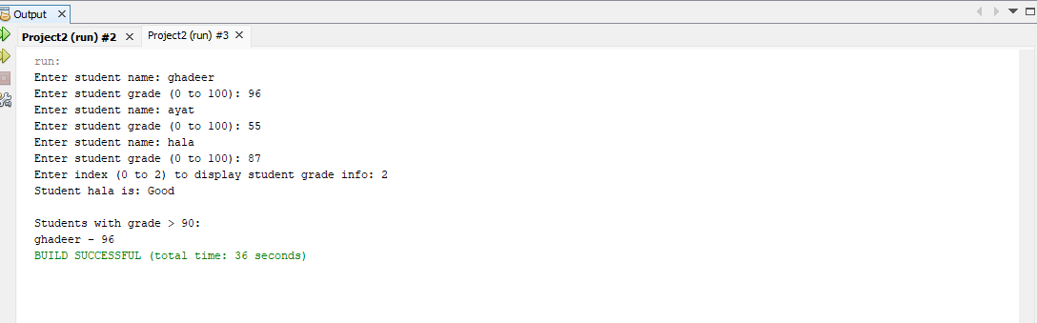

Part 2: write a java in 2 other languages
Question 1: I will choose the ruby and C# languages

python language:

class Student:
def __init__(self, name, grade):
self.name = name
self.grade = grade

def get_name(self):
return self.name

def get_grade(self):
return self.grade

def get_grade_level(self):
if self.grade >= 90:
return "Excellent"
elif self.grade >= 75:
return "Good"
elif self.grade >= 60:
return "Average"
else:
return "Failing"

def main():
students = []

for i in range(3):
name = input("Enter student name: ")
grade = int(input("Enter student grade (0 to 100): "))
students.append(Student(name, grade))

index = int(input("Enter index (0 to 2) to display student grade info: "))

if 0 <= index < len(students):
student = students[index]
print(f"Student {student.get_name()} is: {student.get_grade_level()}")
else:
print("Invalid index!")

print("\nStudents with grade > 90:")
for student in students:
if student.get_grade() > 90:
print(f"{student.get_name()} - {student.get_grade()}")

if __name__ == "__main__":
main()

C # language:

using System;

namespace Project2
{
class Program
{
static void Main(string[] args)
{
Student[] students = new Student[3];

for (int i = 0; i < students.Length; i++)
{
Console.Write("Enter student name: ");
string name = Console.ReadLine();

Console.Write("Enter student grade (0 to 100): ");
int grade = int.Parse(Console.ReadLine());

students[i] = new Student(name, grade);
}

Console.Write("Enter index (0 to 2) to display student grade info: ");
int index = int.Parse(Console.ReadLine());

if (index >= 0 && index < students.Length)
{
string result = students[index].GetGradeLevel();
Console.WriteLine("Student " + students[index].GetName() + " is: " + result);
}
else
{
Console.WriteLine("Invalid index!");
}

Console.WriteLine("\nStudents with grade > 90:");
for (int i = 0; i < students.Length; i++)
{
if (students[i].GetGrade() > 90)
{
Console.WriteLine(students[i].GetName() + " - " + students[i].GetGrade());
}
}
}
}

class Student
{
private string name;
private int grade;

public Student(string n, int g)
{
name = n;
grade = g;
}

public string GetName()
{
return name;
}

public int GetGrade()
{
return grade;
}

public string GetGradeLevel()
{
if (grade >= 90)
return "Excellent";
else if (grade >= 75)
return "Good";
else if (grade >= 60)
return "Average";
else
return "Failing";
}
}
}

Question 2: Maping table from java ----------> python and C#

Purpose | Java | Python | C#
Input student name | scan.nextLine() | input() | Console.ReadLine()
Input student grade | scan.nextInt() | int(input()) | int.Parse(Console.ReadLine())
Create array/list of students | Student[] students = new Student[3]; | students = [] | Student[] students = new Student[3];
Add student to list/array | students[i] = new Student(name, grade); | students.append(Student(name, grade)) | students[i] = new Student(name, grade);
Get index to display info | int index = scan.nextInt(); | index = int(input()) | int index = int.Parse(Console.ReadLine());
Check index validity | if (index >= 0 && index < students.length) | if 0 <= index < len(students): | if (index >= 0 && index < students.Length)
Print student info | System.out.println(...) | print(...) | Console.WriteLine(...)
Loop over students | for (int i = 0; i < students.length; i++) | for student in students: | for (int i = 0; i < students.Length; i++)
Grade classification logic | if (grade >= 90) return "Excellent"; ... | if self.grade >= 90: return "Excellent" | if (grade >= 90) return "Excellent";

